**Vision Document for “MUMSched (replace this with your Project name or title”**

**Team members:**

Mahmoud Gomaa

Mostafa Zaid

Ahmed Abdo

Maiada Mahmoud

**1. Introduction**

Several years ago, auction was done as an event for selling used thing in huge place where the people must be there in person to sell and bid on these products. the auctioneer managed this kind of events manually with papers and pen to keep track of the seller, buyer and the item.

As the number of people who want to sell their stuff for auction increased the need increased on wanting to have a real time tracker for the selling and bidding issues .the auctioneer wanted a method for managing the biding and selling with getting feedback from the bidders on the items they bought.

The auctioneer will be able to handle the seller and customer by activating and deactivate them. The auctioneer can also see the statistics of how many customer and seller participate in actuations during specific period .a seller would be able to offer new products to sell and keep track of the highest price offered and who offered it during the period he specifies to sell the item in it .the auction buyer will be bid on the offered item as long it is available and in the allowed time duration .the buyer can also report a seller if there were any problem .the user and seller will be able to know when the auction is ended and the result.

MUMAuction is new software tool that will allow auctioneer to manage the relationship between buyers and sellers and to view statistics of the profit for the site in specific duration and provide a method for the seller to put there items and for buyers to bid on these items and report the seller if there was a problem in the item.

**2. Positioning**

**2.1 Problem Statement**

*[Provide a statement summarizing the problem being solved by this project. The following format may be*

*used:]*

|  |  |
| --- | --- |
| The problem of | *managing the Compro schedule and allowing students to*  *register for classes* |
| Affects | *administrators, faculty, and students* |
| the impact of which is | *scheduling is complex, must be manually maintained, and*  *changed frequently* |
| a successful solution would be | *one tool which builds a Compro schedule that integrates the*  *business rules for faculty availability and courses needed by*  *students per entry. This tool will provide a Database and a*  *user interface that is easy to use for faculty, staff, and*  *students.* |

**2.2 Product Position Statement**

*[Provide an overall statement summarizing, at the highest level, the unique position the product intends to*

*fill in the marketplace. The following format may be used:]*

|  |  |
| --- | --- |
| For | *[target customer]* |
| Who | *[statement of the need or opportunity]* |
| The (product name) | *is a [product category]* |
| That | *[statement of key benefit; that is, the compelling reason to buy]* |
| Unlike | *[primary competitive alternative]* |
| Our product | *[statement of primary differentiation]* |

*[A product position statement communicates the intent of the application and the importance of the project*

*to all concerned personnel.]*

**3. Stakeholder Descriptions**

**3.1 Stakeholder Summary**

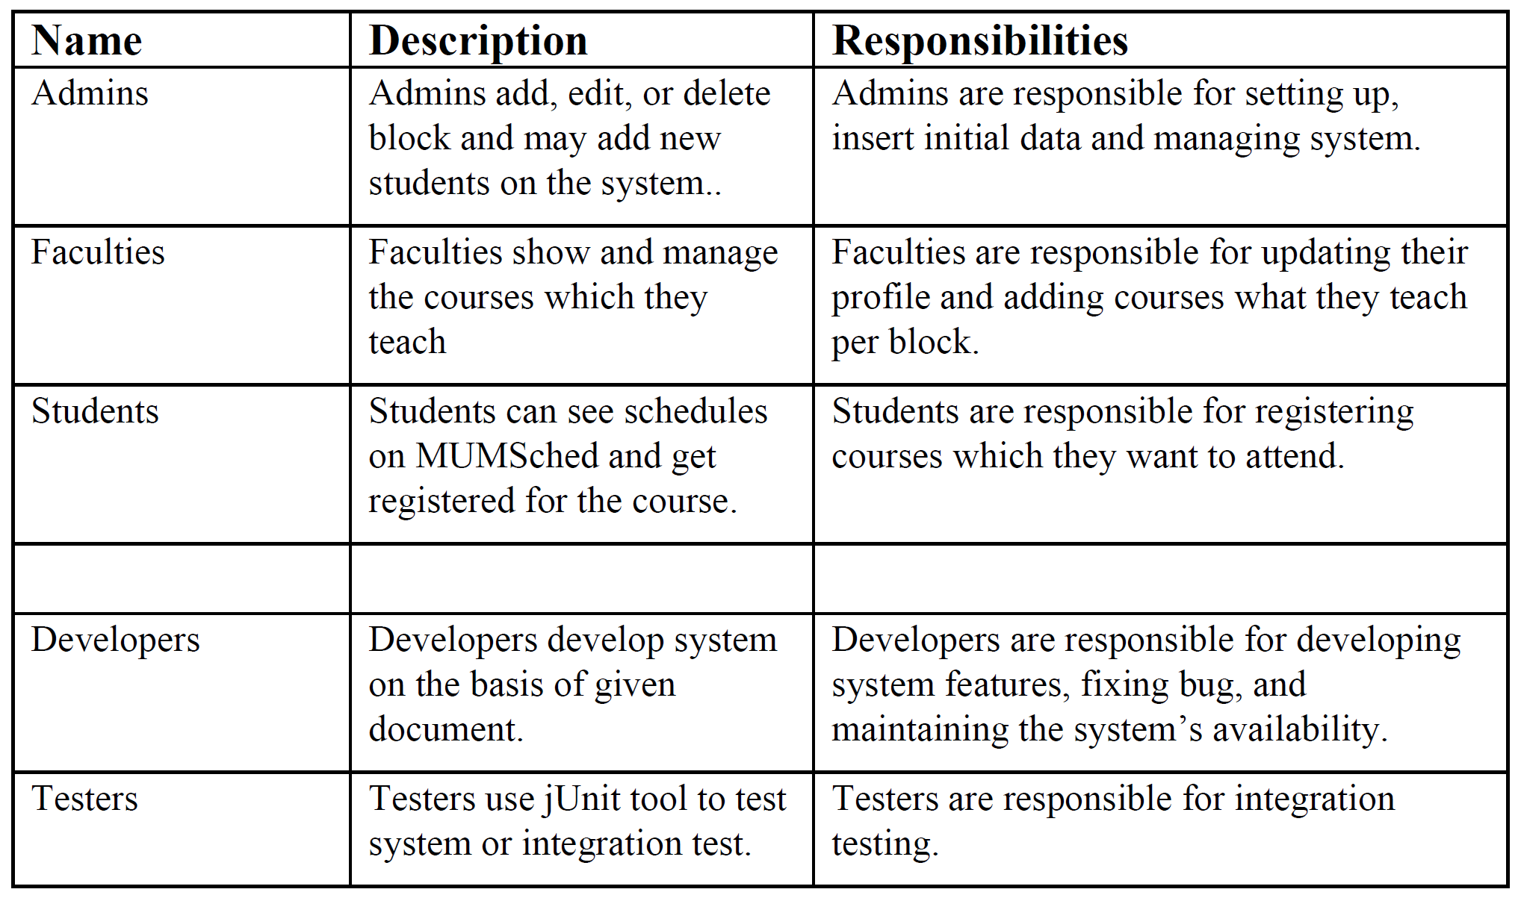

**3.2 User Environment**

*[Detail the working environment of the target user. Here are some suggestions:*

*Number of people involved in completing the task? Is this changing?*

*How long is a task cycle? Amount of time spent in each activity? Is this changing?*

*Any unique environmental constraints: mobile, outdoors, in-flight, and so on?*

*Which system platforms are in use today? Future platforms?*

*What other applications are in use? Does your application need to integrate with them?*

*This is where extracts from the Business Model could be included to outline the task and roles involved,*

*and so on.]*

**4. Product Overview**

**4.1 Product Perspective**

*[This subsection of the* ***Vision*** *document puts the product in perspective to other related products and the*

*user’s environment. If the product is independent and totally self-contained, state it here. If the product is a*

*component of a larger system, then this subsection needs to relate how these systems interact and needs to*

*identify the relevant interfaces between the systems. One easy way to display the major components of the*

*larger system, interconnections, and external interfaces is with a block diagram.]*

**4.2 Assumptions and Dependencies**

*[List each factor that affects the features stated in the* ***Vision*** *document. List assumptions that, if changed,*

*will alter the* ***Vision*** *document. For example, an assumption may state that a specific operating system will*

*be available for the hardware designated for the software product. If the operating system is not available,*

*the* ***Vision*** *document will need to change.]*

**4.3 Needs and Features**

*[Avoid design. Keep feature descriptions at a general level. Focus on capabilities needed and why (not*

*how) they should be implemented.]*

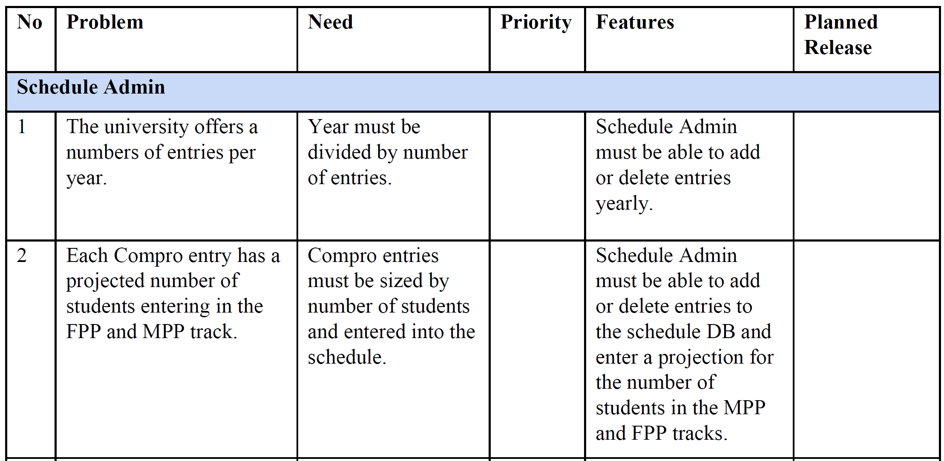

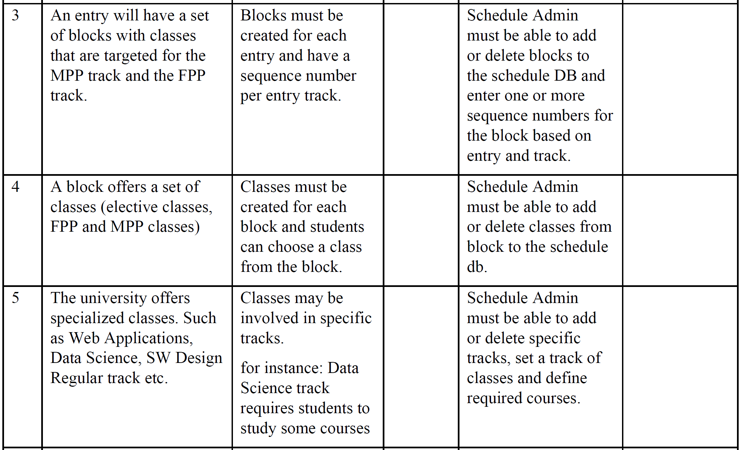

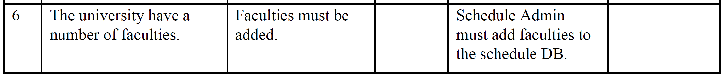

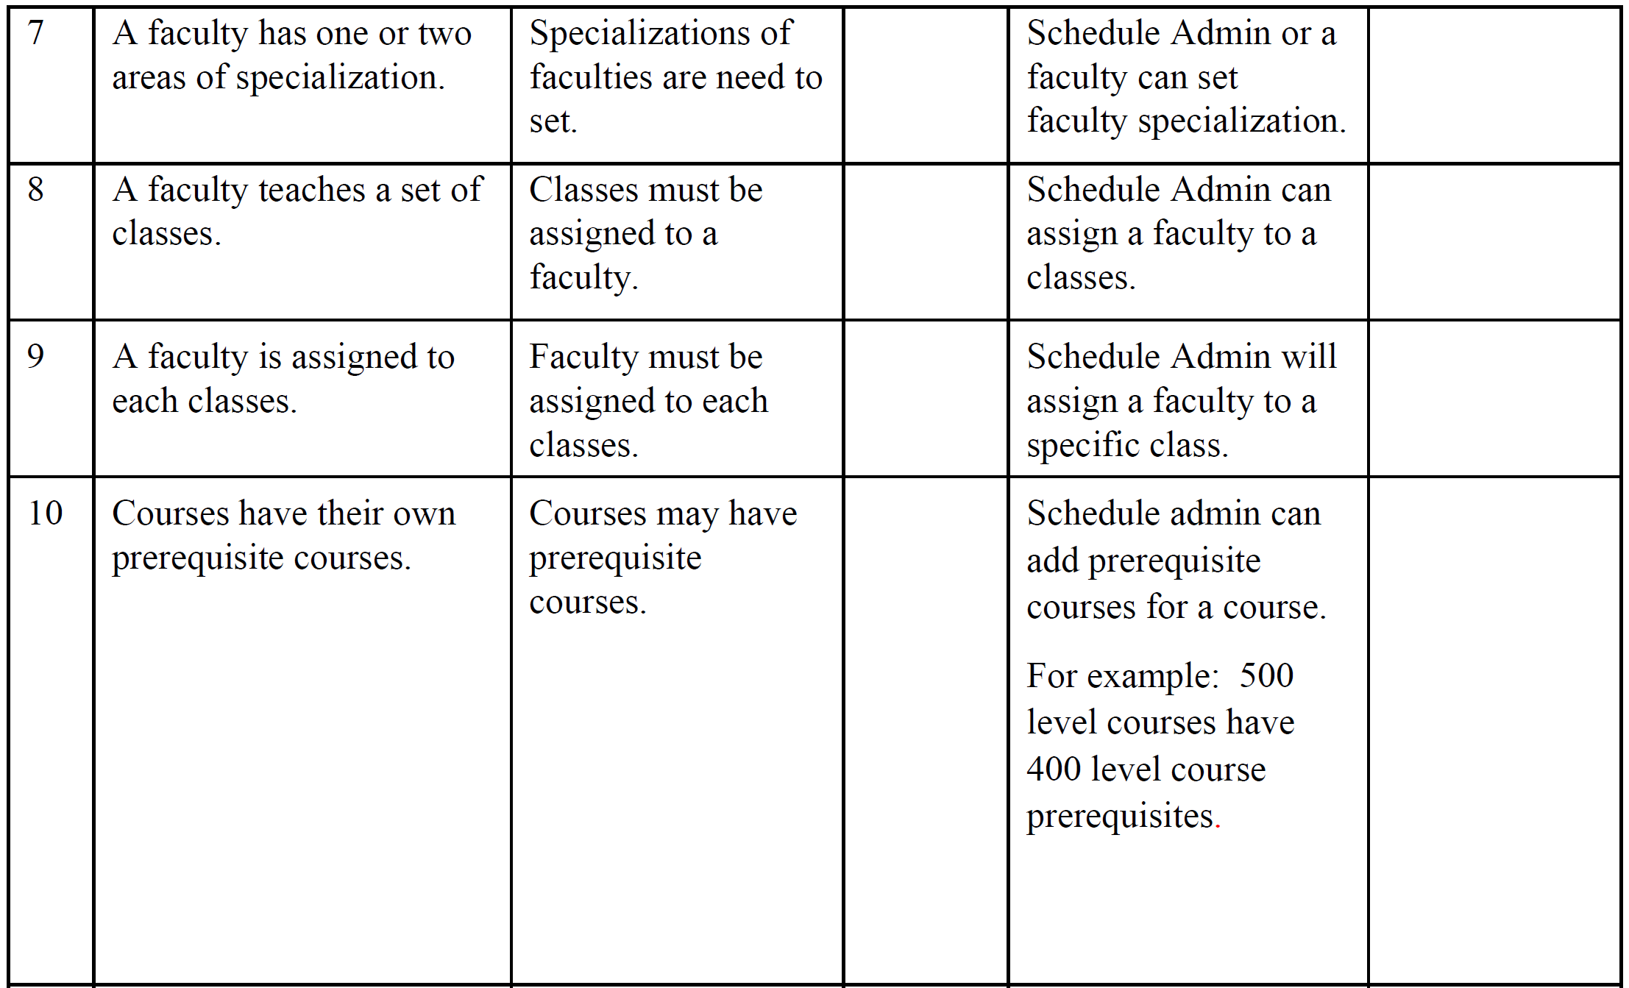

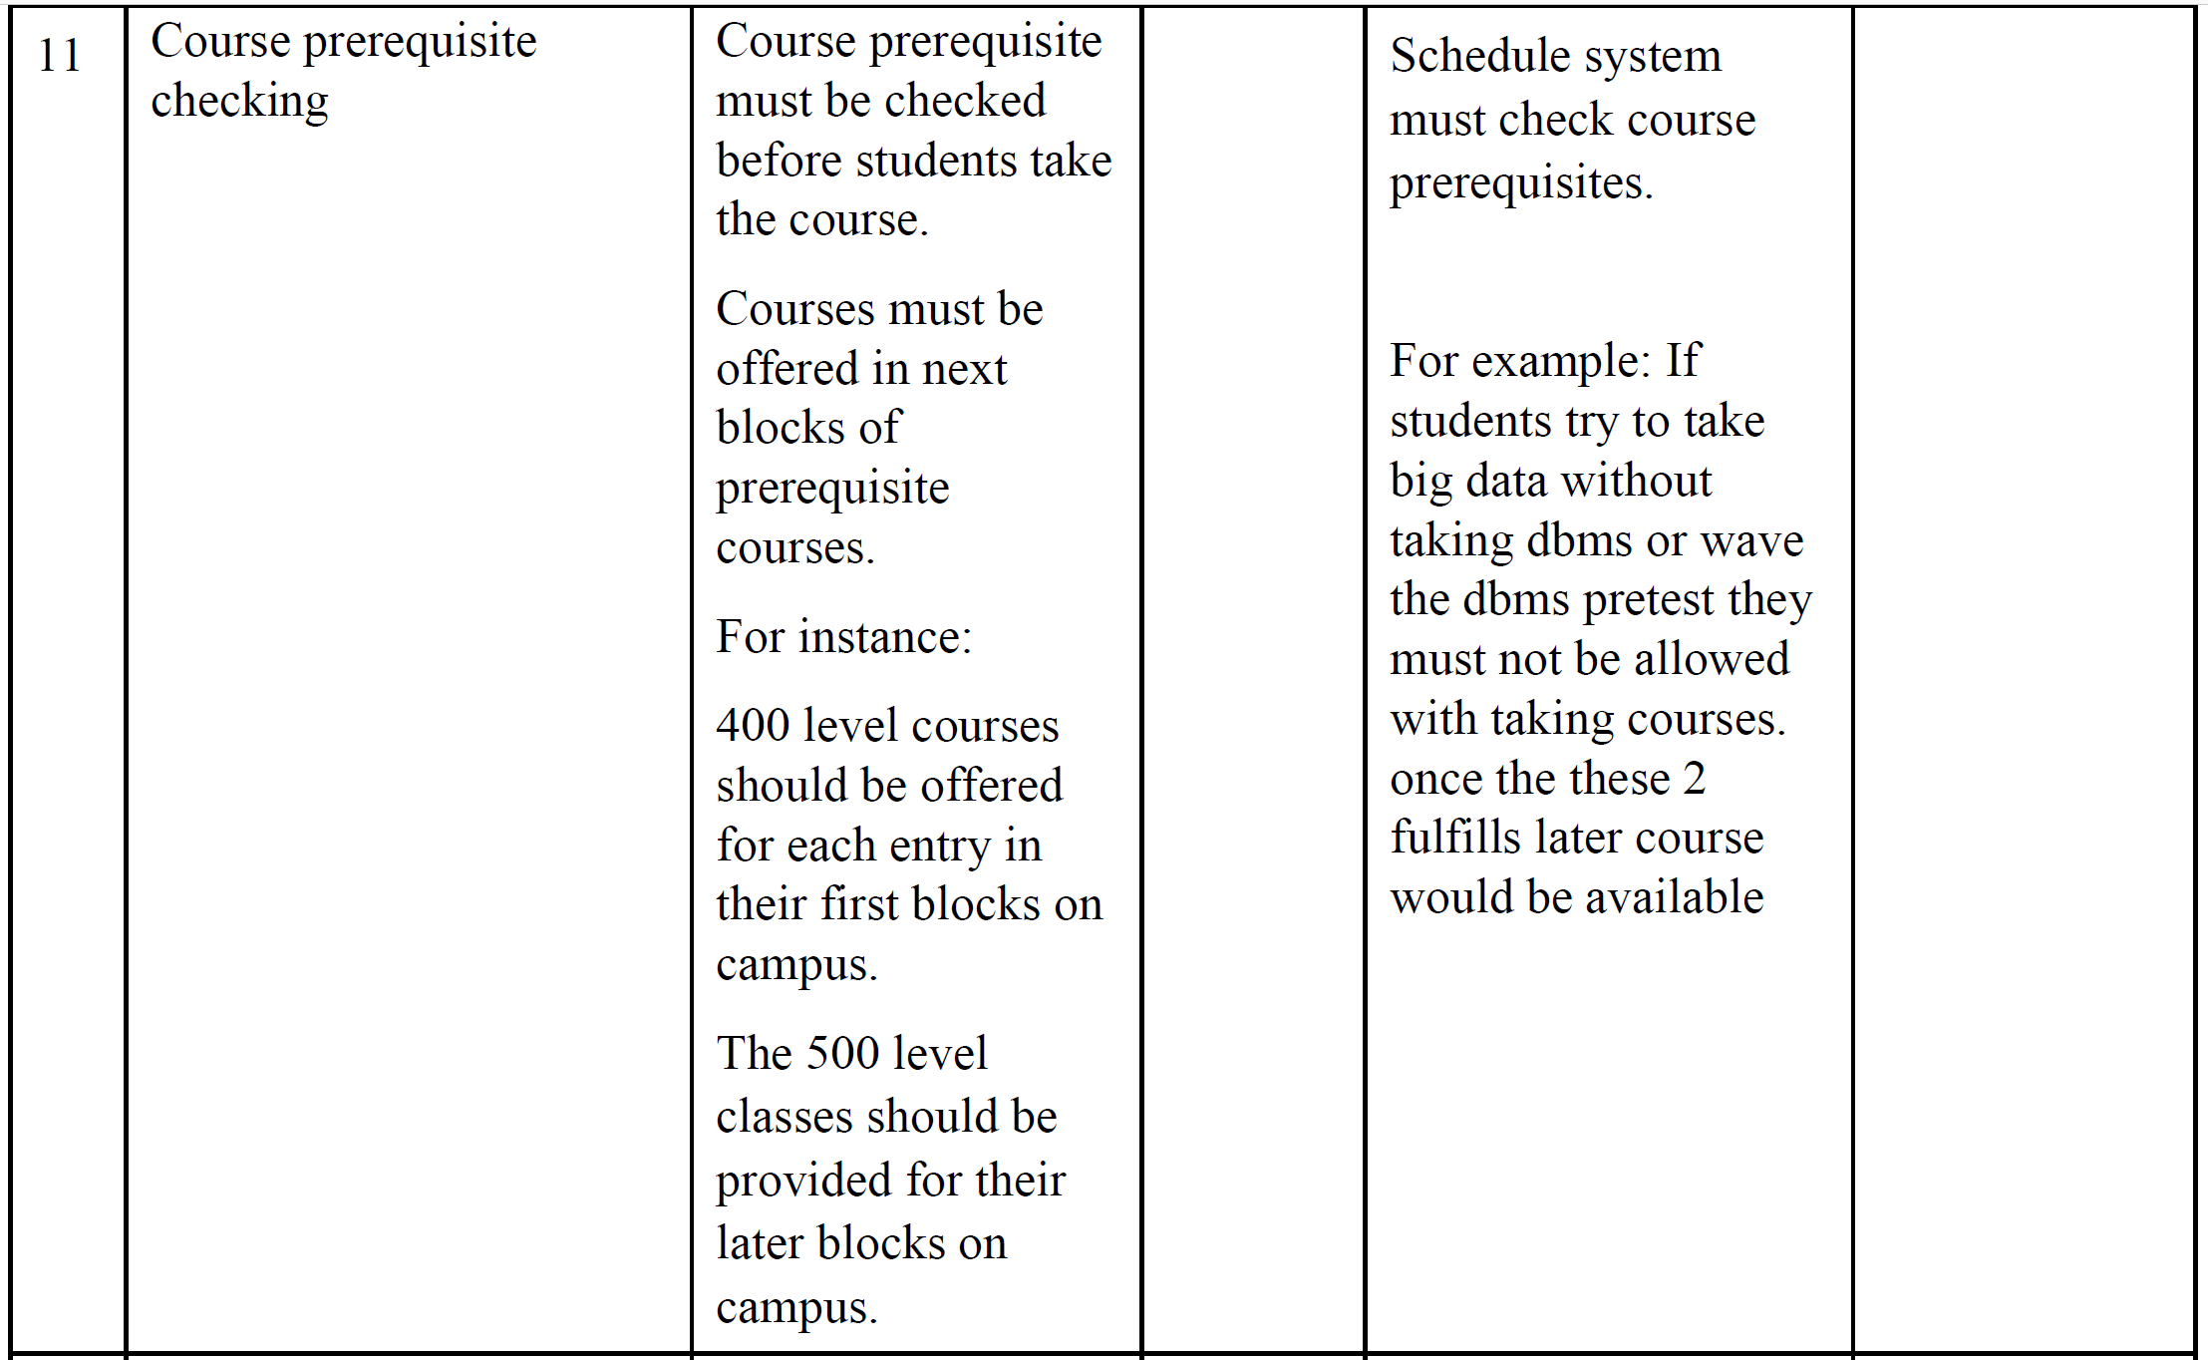

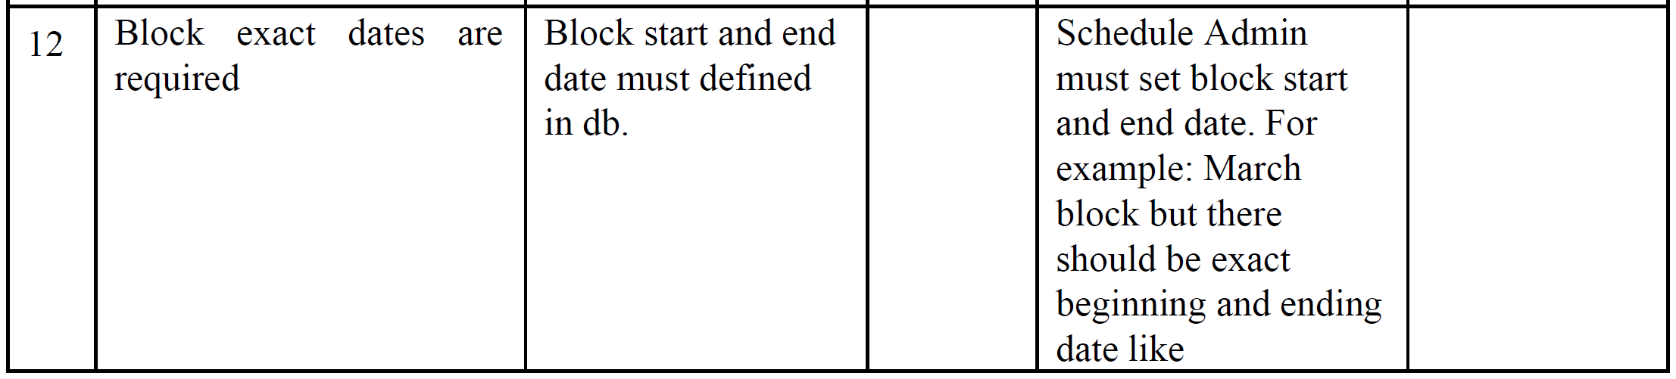

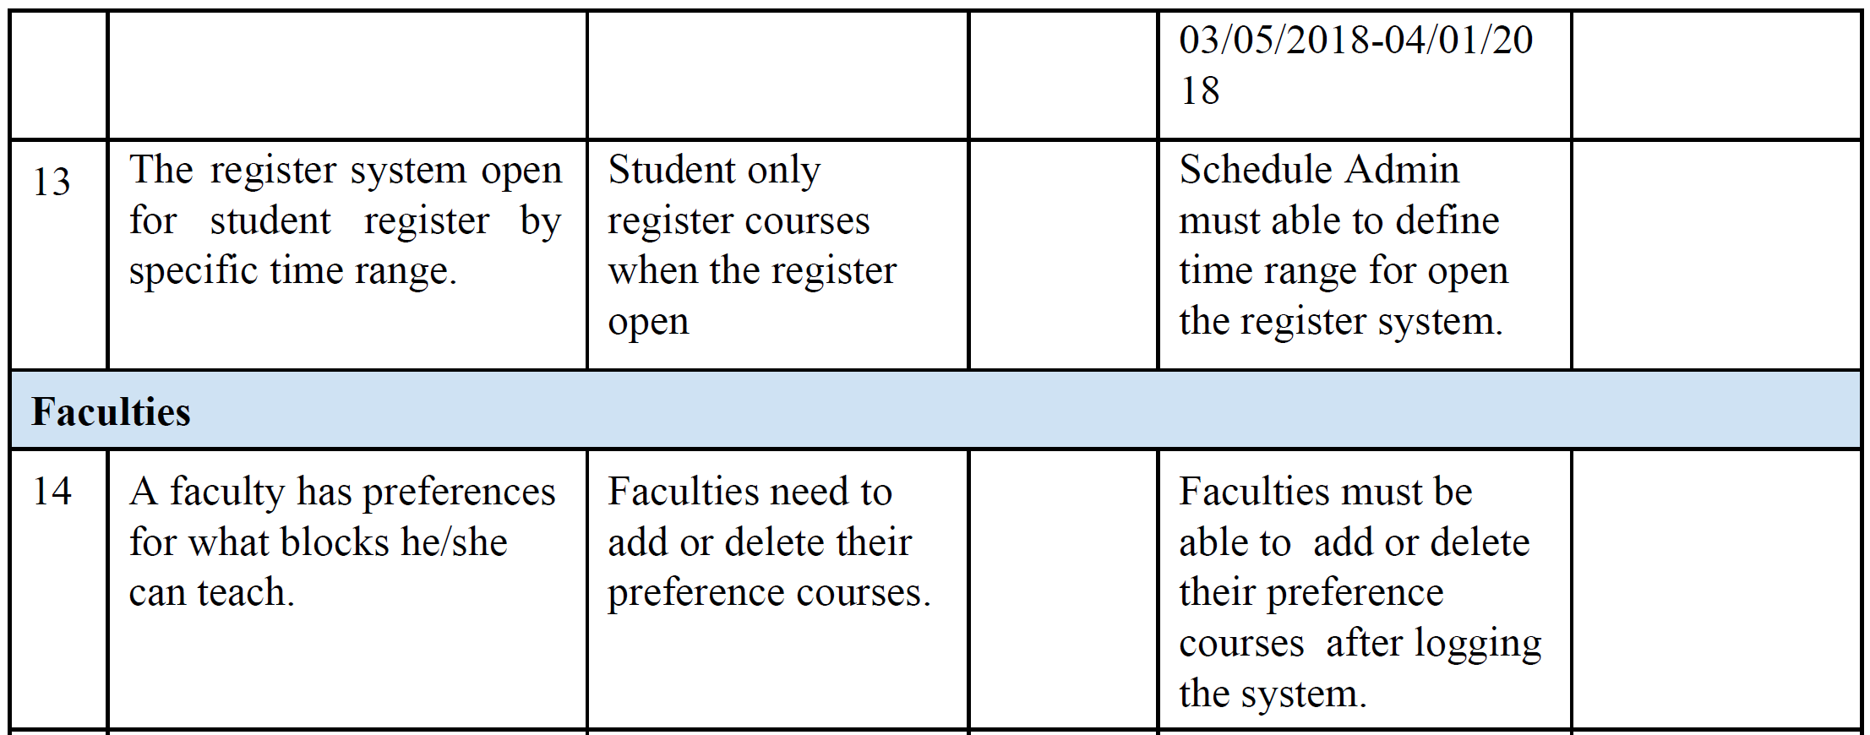

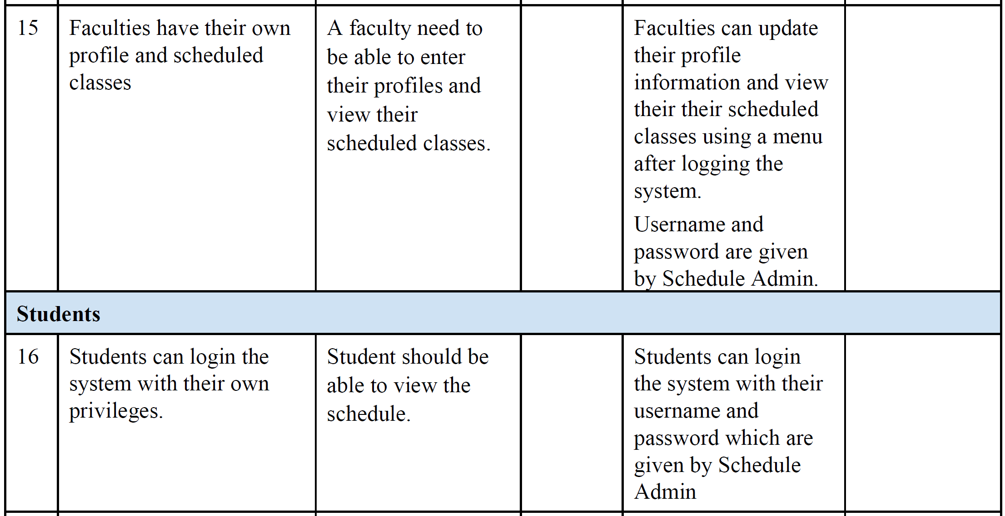

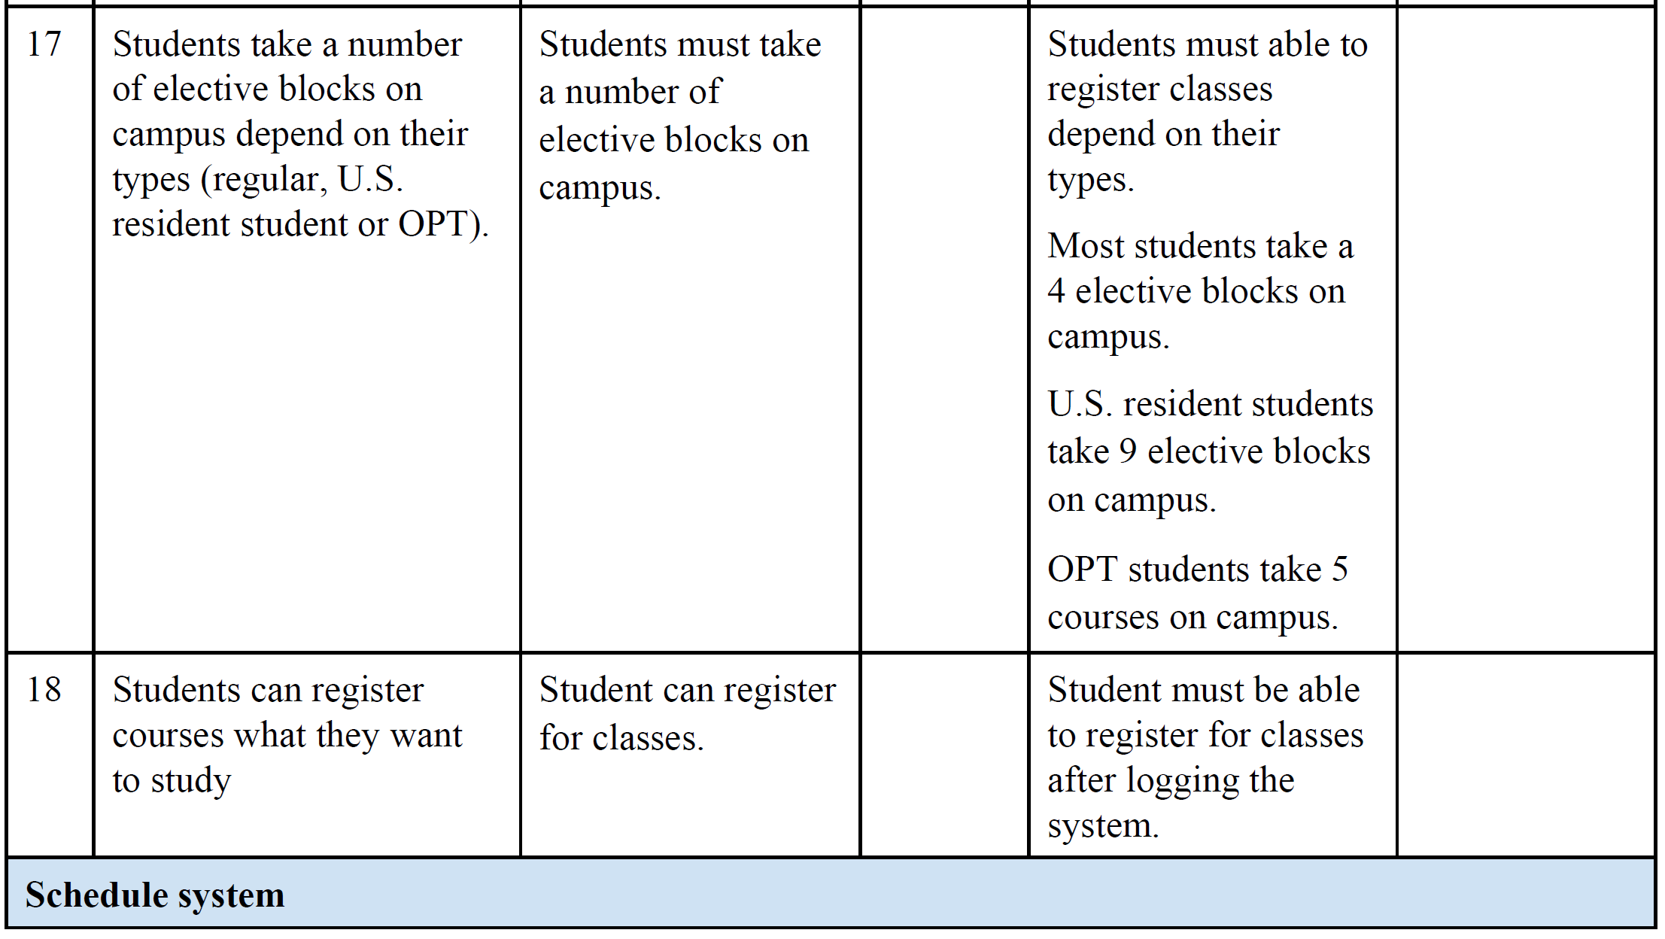

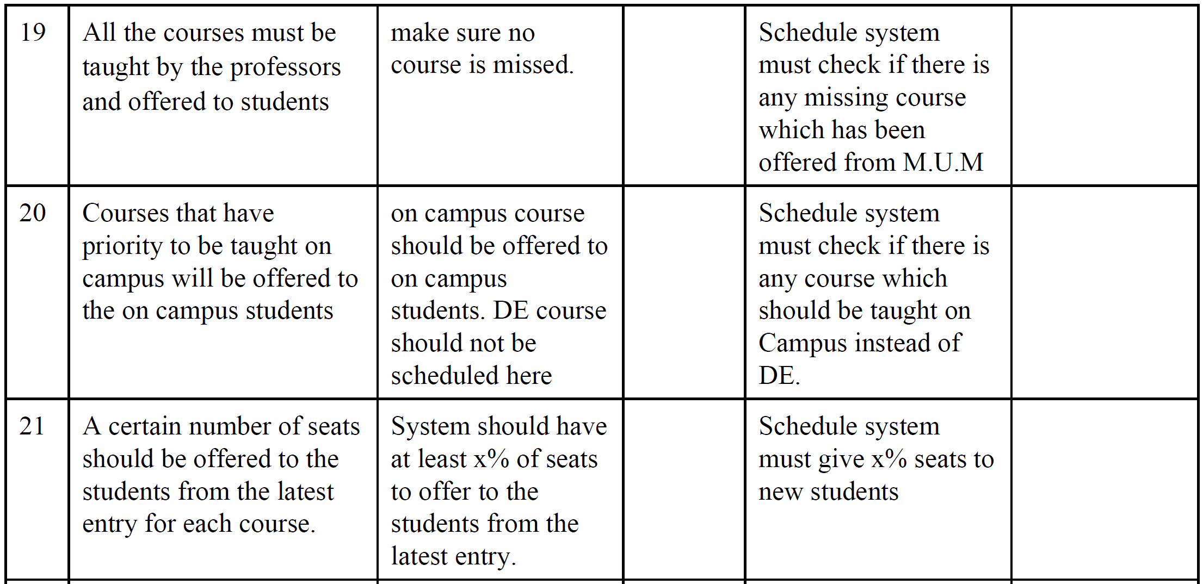

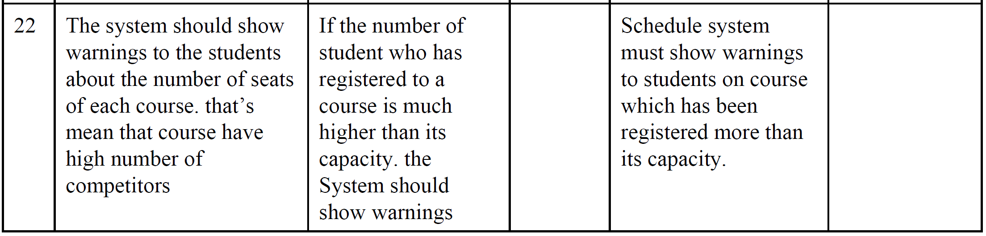

**4.4 Alternatives and Competition**

*[Identify alternatives the stakeholder perceives as available. These can include buying a competitor’s*

*product, building a homegrown solution, or simply maintaining the status quo. List any known competitive*

*choices that exist or may become available. Include the major strengths and weaknesses of each competitor*

*as perceived by the stakeholder or end user.]*

**5. Other Product Requirements**

*[At a high level, list applicable standards, hardware, or platform requirements; performance requirements;*

*and environmental requirements.*

*Define the quality ranges for performance, robustness, fault tolerance, usability, and similar*

*characteristics that are not captured in the Feature Set.*

*Note any design constraints, external constraints, or other dependencies.*

*Define any specific documentation requirements, including user manuals, online help, installation,*

*labeling, and packaging requirements.*

*Define the priority of these other product requirements. Include, if useful, attributes such as stability,*

*benefit, effort, and risk.]*